VoCall: An Open-Source Voice Agent Architecture with Tiered Per-Caller Memory, Emotion Adaptation, and Cross-Tier Erasure for Code-Switched Indian Telephony
Priyanshu Kumar¹, [Co-author Name]¹, [Mentor Name]²
¹ Department of Artificial Intelligence and Data Science, Greater Noida Institute of Technology (GNIOT), Greater Noida, Uttar Pradesh, India (affiliated to AKTU)
² [Mentor designation and department, GNIOT]
Email: [priyanshu@your-domain] · [coauthor@your-domain] · [mentor@gniot.ac.in]
Abstract
Voice agents now answer customer calls in banking, healthcare, and support, and most of them treat every call as a first meeting. Callers repeat their history, the agent cannot hear frustration building, and the stored transcripts raise legal questions the platforms rarely answer. Indian deployments add two more difficulties: callers mix Hindi and English inside a single sentence, and the Digital Personal Data Protection (DPDP) Act 2023 gives callers a right to erasure. This paper presents VoCall, an open-source voice agent architecture that addresses these problems together. VoCall keeps a four-tier memory per caller (an in-call Redis buffer, pgvector semantic facts, Postgres episode summaries, and a FalkorDB contact graph), fuses text and audio emotion estimates on every turn, routes Hindi and Hinglish speech to a dedicated recognizer, and deletes a caller’s data across all four tiers with a single verified request. We evaluate the system with a memory-tier ablation on [dataset D1 and a LoCoMo subset], an emotion comparison of text-only, audio-only, and fused signals on [N] labelled call turns, a word-error-rate comparison on [N] Hinglish utterances, per-stage latency traces from [N] calls, and an erasure probe. [RESULT PLACEHOLDER: the full four-tier configuration reached XX.X% answer accuracy against XX.X% for vector-only retrieval; fused emotion reached XX.X macro-F1 against XX.X for text alone; Hinglish routing cut word error rate from XX.X% to XX.X%; p95 turn latency was XXX ms; erasure completeness was XX%.] We also report where components did not help and what the architecture still cannot guarantee.
Keywords: voice agents; conversational memory; knowledge graph; multimodal emotion recognition; code-switching; DPDP Act 2023; retrieval-augmented generation

I. Introduction
Phone calls remain the main way many people in India reach a bank, a clinic, or a telecom provider, and companies have started to put voice agents on those lines. A typical agent chains a speech-to-text model, a large language model (LLM), and a text-to-speech model. Tools such as Pipecat [16] and LiveKit [17] make the chain easy to assemble, and fast inference keeps the spoken reply under a second.
What the chain lacks is a past. A caller who rang yesterday about a failed refund starts from zero today, and one on their third attempt hears the same cheerful script as a first-time caller. Agent-memory research has moved quickly on text: MemGPT pages information between a working context and external storage [3], Zep keeps facts in a temporal knowledge graph [1], and Mem0 extracts and updates memories, with an optional graph variant [2]. Emotion-aware retrieval exists for text [6], and VoiceMem recently combined a factual graph and an affective graph in a streaming voice setting [5].
Three gaps remain for a deployment like ours. Most memory systems are evaluated on text chat, not on a telephone call with a sub-second turn budget. Hindi-English code-switching is common in Indian speech and is hard for recognizers trained mostly on monolingual data [24], [25]. And memory systems rarely say what happens when a caller asks to be forgotten, although the DPDP Act 2023 [19] and Article 17 of the GDPR [20] both grant that right, and here a caller’s data sits in four stores.
We built VoCall to close these gaps in one open-source system. The claim is deliberately narrow: tiered memory, graph memory, and emotion-aware retrieval each exist in earlier work, so our contribution is the integration and the measurement of what each part adds on a telephone workload. Specifically, we contribute (1) a four-tier per-caller memory retrieved in parallel at call start and written back by a post-call worker; (2) a per-turn emotion pipeline that fuses text and audio estimates, with the audio weight treated as a parameter to test; (3) a language-aware speech route for Hindi, Hinglish, and English; (4) a cross-tier erasure protocol with a probe that checks what remains retrievable afterwards; and (5) an evaluation protocol with scripts, released at [repository URL]. [RESULT PLACEHOLDER: one sentence per headline result from Section IV.]
Section II reviews related work, Section III describes the architecture, data, parameters, and metrics, Section IV reports results, and Section V concludes with limitations and future work.

II. Background and Literature Review

A. Agent memory systems
MemGPT [3] treats the LLM context window like main memory and moves information to and from external storage on demand; it was tested on document analysis and multi-session chat. Takeaway: it motivates tiering, but targets text agents and does not address emotion, voice latency, or deletion.
Zep [1] builds a temporal knowledge graph (Graphiti) over conversations and reports gains over a MemGPT baseline on Deep Memory Retrieval and lower latency on LongMemEval. Takeaway: the closest graph-memory competitor to our fourth tier; text-only, with no erasure procedure reported.
Mem0 [2] extracts and updates salient facts and offers a graph variant, Mem0g; on LoCoMo it reports lower latency and token cost than full-context prompting. Takeaway: its modest graph gain is why we test graph against vector retrieval and do not assume the graph helps.
MIRIX [4] splits memory into several specialised types handled by cooperating agents, and Does Memory Need Graphs? [21] asks when graph structure helps dialogue memory. Takeaway: “first multi-tier memory” is unsafe for any new system, and the value of graphs is an open question that an ablation should answer.

B. Emotion and memory
Emotional RAG [6] retrieves memories that match the emotional state of a role-playing conversation, so emotion-conditioned retrieval already exists in text. MemEmo [7] and ES-MemEval [8] are benchmarks for emotion-related memory in long dialogue. VoiceLongMemEval [9] covers long-term memory in voice and reports that emotion tags help retrieval. VoiceMem [5] is a streaming voice memory with factual and affective graphs and 134 ms retrieval. Takeaway: VoiceMem is the closest system to ours; it builds on trained speech-language models, whereas VoCall is a cascaded telephony pipeline with an in-call Redis tier, connectors, Hinglish routing, and erasure.

C. Emotion fusion, intent, and speech
Deschamps-Berger et al. [10] fuse acoustic and text features with attention for emotion recognition on emergency-call recordings. Takeaway: text-plus-audio fusion is established, so our contribution is a measured comparison inside a live agent loop. Audio emotions are mapped to valence and arousal with Russell’s circumplex model [11]. IntentionESC [12], MC-EIU [13], and AffectMind [14] link intent with emotion; they underlie our deliberately lightweight intent module. LoCoMo [15] and LongMemEval [22] test long conversational memory; HNSW [23] and retrieval-augmented generation [26] underlie our second tier. For speech, Whisper [27] gives broad multilingual coverage, while the IITG-HingCoS corpus [24] and a recent survey [25] document how hard code-switching is. Takeaway: none of these tests a telephone agent as a whole, which is the workload we measure.

E. Voice-agent platforms
Vapi [28] and Retell [29] are hosted platforms for phone and web voice agents; Retell scores each call after it ends and returns a caller-sentiment field [32]. Takeaway: sentiment arrives after the call, and the sources reviewed describe no per-caller memory across calls and no erasure procedure. Bolna [30] is an MIT-licensed orchestration platform that connects speech, language, and synthesis providers with telephony such as Twilio and Exotel; its hosted service lists Hindi and Hinglish [33]. Takeaway: the closest open-source, India-oriented platform; the sources reviewed describe no tiered memory, fused emotion, or erasure. LiveKit Agents [17] and Pipecat [16] are open-source frameworks, and a LiveKit plugin adds real-time emotion tags from an external service to the transcript passed to the LLM [31]. Takeaway: live emotion in an open-source agent already exists, so our contribution is the measured comparison of text, audio, and fused signals with threshold-driven behaviour, not live emotion itself.
TABLE I summarises how these works compare. “NR” means not reported in the sources reviewed (papers or documentation).
TABLE I. Comparison of related systems with VoCall.
Work | Memory structure | Emotion | Voice / real-time | Erasure
MemGPT [3] | Paged context + external store | No | No | NR
Zep [1] | Temporal knowledge graph | No | No | NR
Mem0 / Mem0g [2] | Extracted facts; optional graph | No | No | NR
MIRIX [4] | Several specialised memory types | NR | No | NR
Emotional RAG [6] | Emotion-matched retrieval | Yes | No | NR
VoiceMem [5] | Factual + affective graphs | Yes | Yes | NR
Vapi [28] | NR | NR | Yes | NR
Retell [29], [32] | NR | Post-call sentiment | Yes | NR
Bolna [30] | NR | NR | Yes | NR
LiveKit + emotion plugin [31] | NR | Yes (audio tags, external API) | Yes | NR
VoCall (ours) | Four tiers (Redis, pgvector, Postgres, FalkorDB) | Yes (fused) | Yes (telephony) | Yes (probe-tested)

III. Methodology

A. System overview
Fig. 1 shows the architecture. Callers arrive from a browser through LiveKit or from the telephone network through Twilio, Exotel, or Plivo. A Pipecat pipeline runs the turn loop, a FalkorDB [18] graph holds per-contact relationships, and a FastAPI service handles sessions, configuration, and erasure. When a call ends, a Trigger.dev worker summarises it and writes to the memory tiers and the configured connectors (calendar, CRM, Slack, WhatsApp, webhook). Both ingress paths run the same turn loop. The browser path needs no phone number or carrier account, so the system can be exercised without telephony provisioning. Hosted platforms offer the same convenience: Vapi starts a web call from its dashboard without a phone number [28], and Retell’s web test needs no number and has no telephony charge, although it bills voice minutes at production rates [29], [34]. Browser calls cannot exercise carrier behaviour such as phone transfers or SMS [29], so results from this path do not cover carrier audio quality or transfers.
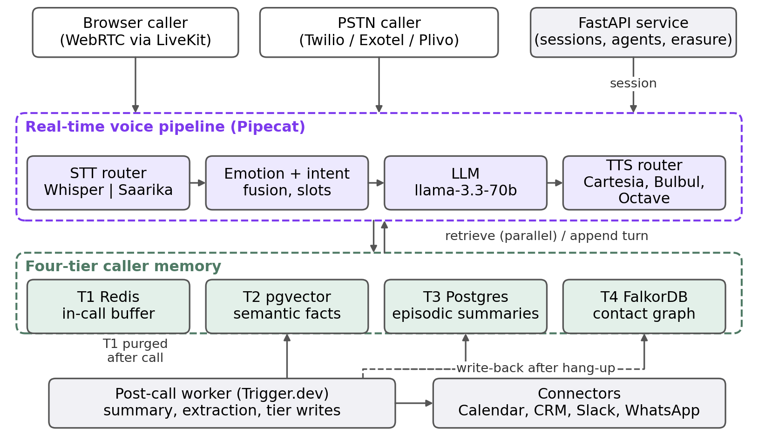
Fig. 1. VoCall architecture: ingress, real-time voice pipeline, four-tier caller memory, post-call worker, and connectors.

B. Turn pipeline and latency model
Fig. 2 gives the flow for one caller turn. Audio is resampled to 16 kHz and routed by language to Whisper (English) or Saarika (Hindi, Hinglish). Once the transcript exists, four branches run in parallel: text emotion, audio emotion, intent and slots, and memory retrieval. Their outputs are merged into one prompt, the LLM streams a reply, a TTS route speaks it, and the turn is appended to the Redis buffer. Because the branches overlap, the time to first audio byte is
$$T_{\text{turn}}=T_{\text{stt}}+max\left(T_{\text{emo}}, T_{\text{mem}}, T_{\text{int}}\right)+T_{\text{llm}}^{\text{ttft}}+T_{\text{tts}}^{\text{ttfab}}+T_{\text{net}} \left(1\right)$$
and the design target is a p95 value below 800 ms.
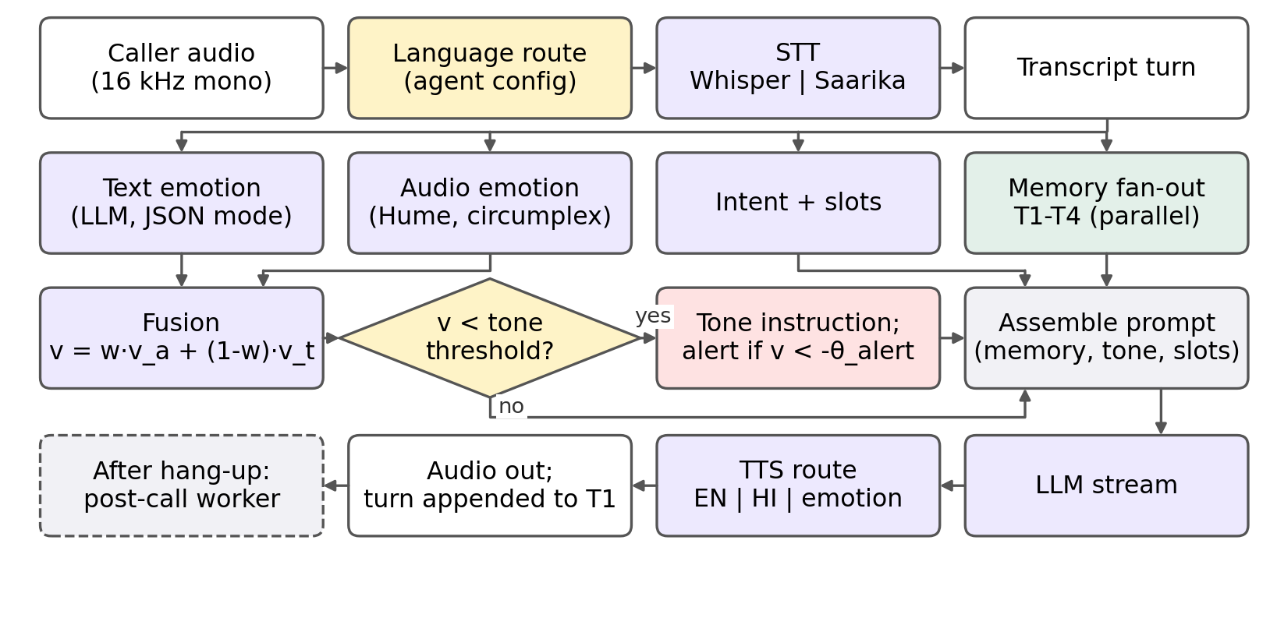
Fig. 2. Flowchart of one caller turn, from audio frame to spoken reply.

C. Four-tier caller memory
TABLE II lists the tiers. Retrieval at call start fans out to all tiers with asyncio.gather; a failed tier returns an empty result instead of an error.
TABLE II. The four memory tiers.
Tier | Store | Contents | Retrieval
T1 | Redis (Upstash) | Current-call turns, emotion state, slots | Key lookup stm:{call_id}
T2 | Postgres + pgvector | Embedded facts and preferences | Cosine top-$k$, threshold $τ$
T3 | Postgres | Per-call summaries, outcomes | Most recent $m$ episodes
T4 | FalkorDB | Contact graph (Fig. 3) | Cypher query per contact
For T2, a query embedding $q$ is compared with each stored fact embedding $f$ by cosine similarity,
$$sim\left(q,f\right)=\frac{q⋅f}{∥q∥ ∥f∥} \left(2\right)$$
and the retrieved set is the $k$ most similar facts of the same contact whose similarity is at least $τ$:
$$R_{k}\left(q\right)={Top}_{k}\left(\left\{f∈F_{c}:sim\left(q,f\right)≥τ\right\}\right) \left(3\right)$$
An HNSW index [23] keeps the lookup fast; the embedding model is [CONFIRM: model name and dimension].
T4 stores one graph per contact (Fig. 3). Three Cypher queries return recent episodes with their entities, the contact’s most frequent frustration topics with counts and the last emotion state, and the links between consecutive episodes, so the agent can know that billing has frustrated this caller before.
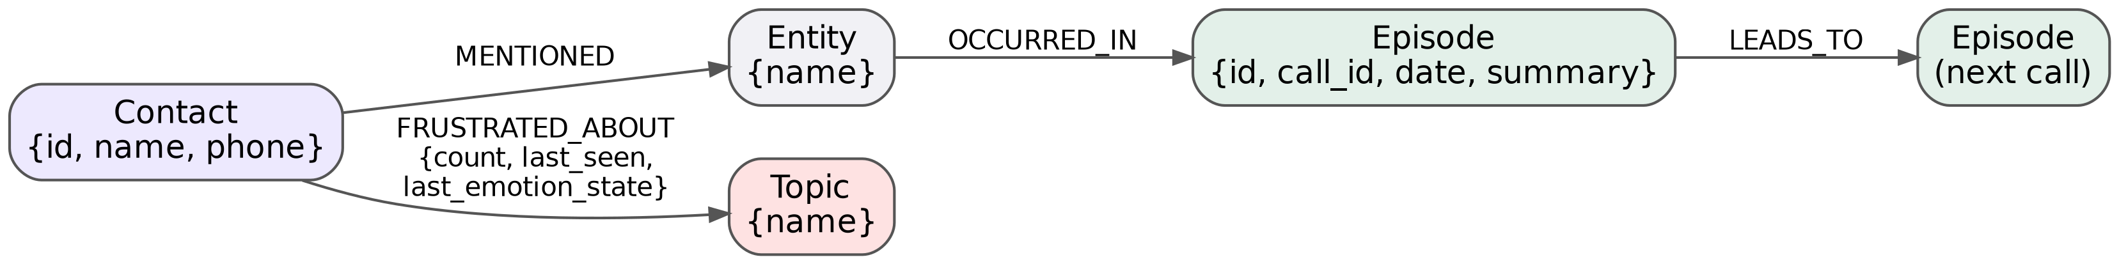
Fig. 3. Per-contact graph schema in FalkorDB.
The retrieved results are rendered as a text block and appended to the base prompt with the tone instruction and the filled slots:
$$P_{\text{final}}=P_{\text{base}}⊕M\left(R_{k},E_{m},G_{c}\right)⊕I_{\text{tone}}⊕S \left(4\right)$$
where $E_{m}$ are the recent episodes, $G_{c}$ the graph context, $I_{\text{tone}}$ the tone instruction, and $S$ the slot state. After hang-up, the worker summarises the call, extracts entities and topics, embeds new facts, writes T2, T3, and T4, fires the post-call connectors, and purges T1.

D. Emotion pipeline
The text signal comes from an LLM call in JSON mode that returns valence, arousal, a dominant label, and a confidence. The audio signal comes from the Hume expression API, which returns scores $s_{i}$ for a set of emotions; each emotion has a fixed circumplex coordinate $\left(v_{i},a_{i}\right)$ [11], and the audio valence is the score-weighted centroid:
va=i​si vii​si, aa=i​si aii​si 5
When both signals exist, they are blended with an audio weight $w$:
$$v=w v_{a}+\left(1−w\right) v_{t}, a=w a_{a}+\left(1−w\right) a_{t} \left(6\right)$$
The deployed value is $w=0.6$, and Section IV tests it against other values. If no Hume key is configured, the system falls back to the text signal alone. A frustration score $F=max\left(0,−v\right)$ drives two behaviours. When $v<−0.4$, a tone instruction asking for extra empathy and patience is added to the prompt; below $−0.6$ a stronger instruction asks the agent to acknowledge the frustration and use shorter sentences, and above $+0.6$ a warm, conversational instruction is used. When $v<−θ_{a}$, an alert connector can notify a supervisor or start a human handoff. The thresholds are in TABLE IV.

E. Intent, slots, and language routing
A JSON-mode LLM call classifies each turn into a fixed or agent-defined intent, extracts slot values, and returns a one-line statement of the intent. Slots persist in Redis across turns and interruptions, and when every required slot is filled and the intent confidence is at least 0.70 the resolver fires the configured connector, such as a calendar booking. A small rule table combines intent and emotion; a refund request with strongly negative valence, for example, triggers a human handoff. The module follows [12]-[14] and is not evaluated as a contribution. Language is fixed in the agent configuration: Hindi and Hinglish agents use Saarika and Bulbul, English agents use Whisper and Cartesia, and code-switched agents are told to answer in the caller’s language mix. If Sarvam is unavailable, recognition falls back to Whisper and synthesis to Cartesia; if Hume is unavailable, emotion falls back to the text signal and synthesis to Cartesia.

F. Cross-tier erasure protocol
A request to erase a contact removes the contact’s data from each store in turn and then checks the result. Algorithm 1 gives the steps.
Algorithm 1 ERASE(contact c)
1: n_before <- PROBE(c) # items retrievable, per tier
2: T1: delete Redis keys of c's calls
3: T2: DELETE FROM memory_long_term WHERE contact_id = c
4: T3: DELETE FROM memory_episodic WHERE contact_id = c
5: T4: Cypher DETACH DELETE c, its episodes, frustration events
6: n_after <- PROBE(c) # same queries as step 1
7: write audit record (hashed id, time, counts)
8: return C = 1 - sum(n_after) / sum(n_before)
The probe issues the retrieval queries the agent uses at call start (T1 key scan, T2 similarity search with seeded queries, T3 episode fetch, T4 Cypher context query) and counts what returns. Completeness is
$$C=1−\frac{\sum_{t=1}^{4}{n_{t}^{\text{after}}}}{\sum_{t=1}^{4}{n_{t}^{\text{before}}}} \left(7\right)$$
and the target is $C=1$. The protocol covers VoCall’s own stores. Audio or text already sent to third-party providers (speech, LLM, and TTS vendors) is outside it, a limit we return to in Section V.

G. Datasets
TABLE III lists the datasets. We do not have a public benchmark that covers telephone memory, emotion, and Hinglish together, so D1, D3, and D4 are built for this study.
TABLE III. Datasets used in the evaluation. Entries in brackets are to be filled.
ID | Purpose | Source and construction | Size
D1 | Memory ablation | Synthetic caller histories: scripted personas, [N] calls each, seeded facts and recurring complaints; questions written from the seeds | [N] callers, [N] questions
D2 | Memory ablation (public) | Subset of LoCoMo [15] | [N] conversations
D3 | Emotion signals | Role-played calls recorded by the team, plus [public emotion corpus]; labelled by [k] annotators | [N] turns
D4 | Hinglish recognition | [IITG-HingCoS [24] subset (8 kHz, telephone-band) and/or self-recorded phone-quality audio] | [N] utterances
D5 | Latency | Traces from live calls over [network type] | [N] calls
For D1, a language model writes each call from a persona sheet, and the seeds (facts, preferences, repeated complaints) serve as ground truth. D3 labels use a [5]-point valence scale and a categorical label, with agreement reported as Cohen’s $κ$.

H. Parameters
TABLE IV gives the settings used in all experiments unless a sweep says otherwise.
TABLE IV. Experimental parameters.
Parameter | Symbol | Value
Facts retrieved from T2 | $k$ | 5
Similarity threshold | $τ$ | 0.75
Episodes retrieved from T3 | $m$ | 3
Audio weight in fusion | $w$ | 0.6 (swept 0 to 1)
Tone-instruction thresholds (mild / strong) | $θ_{t}$ | 0.4 / 0.6
Alert threshold | $θ_{a}$ | 0.7
LLM (primary / fallback) | n/a | llama-3.3-70b on Groq / Cerebras

I. Evaluation metrics
Dataset-related. Size, class balance, and annotator agreement ($κ$) for D1 and D3, plus a manual realism check of [N] sampled D1 conversations.
Memory. Answer accuracy is the share of questions answered correctly, judged by [exact match / an LLM judge validated on a sample]. Retrieval quality is Recall@$k$,
Recall@k=1Qq∈Q​Rkq∩GqGq 8
where $G_{q}$ is the set of gold facts for question $q$. We also report prompt tokens per call and retrieval latency.
Emotion and intent. Macro-F1 over emotion classes, mean absolute error of valence, and Pearson $r$ with annotator valence. For intent we use micro-F1, and the joint recognition balance metric
$$\text{JRBM}=\frac{2 F_{1}^{\text{emo}} F_{1}^{\text{int}}}{F_{1}^{\text{emo}}+F_{1}^{\text{int}}} \left(9\right)$$
Speech and latency. Word error rate,
$$\text{WER}=\frac{S+D+I}{N} \left(10\right)$$
with $S$, $D$, $I$ the substitutions, deletions, and insertions against $N$ reference words. Latency is reported as p50 and p95 per stage and for the full turn, from Eq. (1).
Erasure. Completeness $C$ from Eq. (7), plus the number of tiers with any residue.

IV. Results and Discussion
All numbers here are placeholders until the experiments are run; bracketed text marks where measured values and explanations go.

A. Memory-tier ablation
TABLE V compares memory configurations on D1 and D2. Fig. 4(a) plots the same comparison.
TABLE V. Memory-tier ablation (placeholder values).
Configuration | Accuracy D1 (%) | Accuracy D2 (%) | Recall@5 | Tokens / call | Retrieval ms
No memory | [XX.X] | [XX.X] | n/a | [XXX] | 0
T2 vector only | [XX.X] | [XX.X] | [X.XX] | [XXX] | [XX]
T2 + T3 | [XX.X] | [XX.X] | [X.XX] | [XXX] | [XX]
T2 + T3 + T4 (graph) | [XX.X] | [XX.X] | [X.XX] | [XXX] | [XX]
Full (T1 to T4) | [XX.X] | [XX.X] | [X.XX] | [XXX] | [XX]
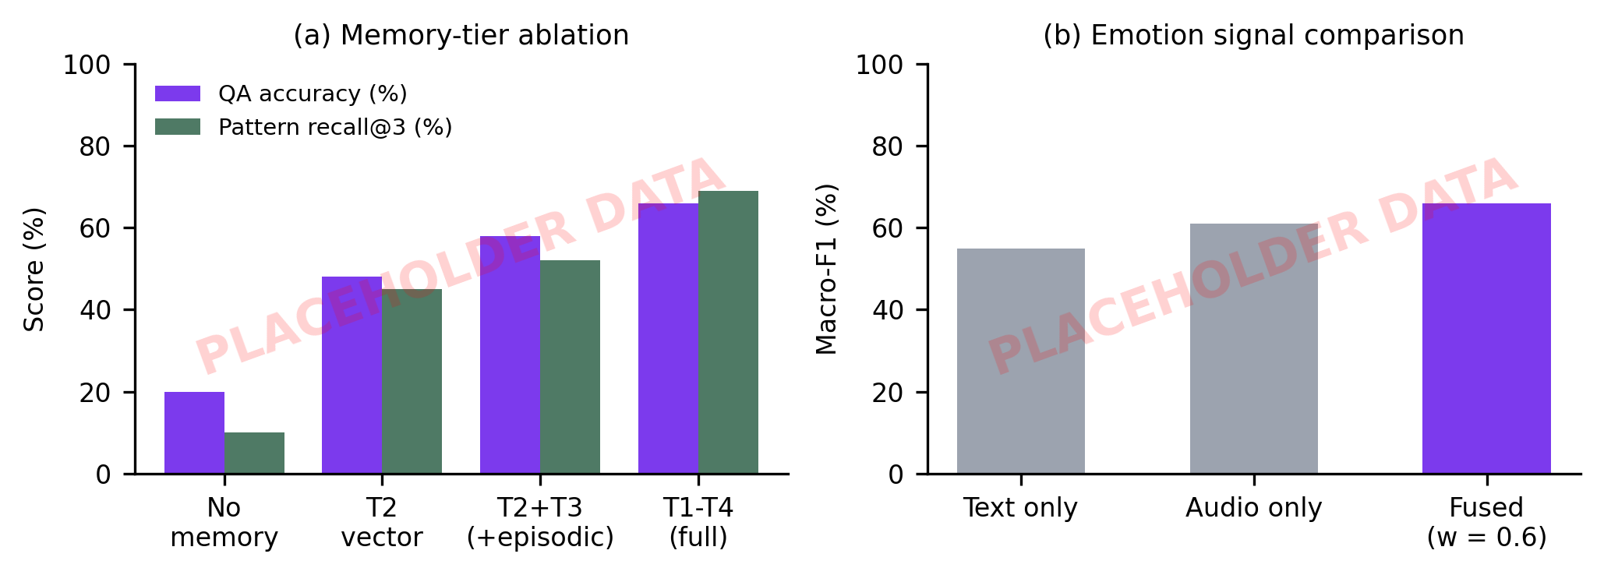
Fig. 4. (a) Memory-tier ablation and (b) emotion signal comparison. Charts show placeholder data.
[After measuring: which tier added the most accuracy, split by question type. Report repeated-complaint questions separately, since a graph should help there and a vector store should not. If the graph adds nothing, say so and give the likely reason.]

B. Emotion signals and fusion weight
TABLE VI reports emotion recognition on D3 for each signal and for the fused estimate. Fig. 4(b) shows the macro-F1 comparison and Fig. 5(b) the sweep over $w$.
TABLE VI. Emotion recognition on D3 (placeholder values).
Signal | Macro-F1 | Valence MAE | Pearson $r$ | Added latency (ms)
Text only (LLM) | [X.XX] | [X.XX] | [X.XX] | [XXX]
Audio only (Hume) | [X.XX] | [X.XX] | [X.XX] | [XXX]
Fused, $w=0.6$ | [X.XX] | [X.XX] | [X.XX] | [XXX]
Fused, best $w$ from sweep | [X.XX] | [X.XX] | [X.XX] | [XXX]
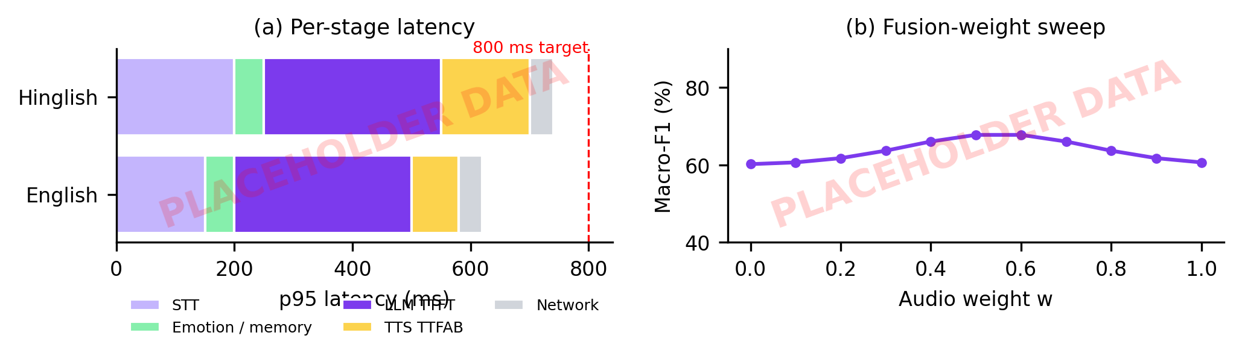
Fig. 5. (a) p95 latency by pipeline stage for English and Hinglish, with the 800 ms target; (b) emotion macro-F1 as the audio weight $w$ varies. Charts show placeholder data.
[After measuring: whether fusion beat both single signals, whether $w=0.6$ was near the best value, and where the signals disagreed. If one signal wins alone, report it and drop the fusion claim.]

C. Hinglish recognition
TABLE VII compares the two recognizers on D4.
TABLE VII. Word error rate (%) on D4 (placeholder values).
System | Hindi | Hinglish | English | Latency (ms)
Whisper large-v3 (Groq) | [XX.X] | [XX.X] | [XX.X] | [XXX]
Saarika v2 (Sarvam) | [XX.X] | [XX.X] | [XX.X] | [XXX]
Language-routed (VoCall) | [XX.X] | [XX.X] | [XX.X] | [XXX]
[After measuring: where routing helped, and the text normalization rules used before computing WER.]

D. Latency
Fig. 5(a) breaks the full turn into stages. [Report p50 and p95 for English and Hinglish, the dominant stage, whether the 800 ms target held, and the network and region used.]

E. Erasure
TABLE VIII reports the erasure probe on [N] test contacts, each seeded with facts, episodes, and graph nodes.
TABLE VIII. Items retrievable before and after erasure (placeholder values).
Tier | Items before (mean) | Items after (mean) | Contacts with residue
T1 Redis | [X] | [X] | [X]
T2 pgvector | [X] | [X] | [X]
T3 Postgres | [X] | [X] | [X]
T4 FalkorDB | [X] | [X] | [X]
Completeness $C$ | n/a | n/a | [X.XX]
[After measuring: any residue and its cause, such as a Redis key from a call still in progress.]

F. Comparative analysis
[After measuring: rank memory tiers, graph, emotion fusion, and language routing by what each added, and whether it earned its cost in latency and complexity. Compare with Zep [1], Mem0 [2], and VoiceMem [5] only where benchmark and setup match.]

V. Conclusion and Future Work
VoCall puts four kinds of caller memory, a per-turn emotion signal, a language-aware speech route, and a verified erasure path into one open-source voice agent. The paper does not claim any of these ideas as new alone, since earlier systems cover tiered memory, graph memory, emotion-aware retrieval, and text-audio fusion. What it adds is an integrated telephone system and a measured account of which parts pay for themselves. [Replace with two or three sentences stating the measured conclusion, including any component that did not help.]
The work has limits. D1 is synthetic and D3 and D4 are small, so the numbers say more about the pipeline than about real call traffic. The system depends on third-party services for speech, language, and emotion, and erasure covers only VoCall’s own stores; audio and text already sent to those vendors is outside the protocol. Tone adaptation was checked for correct triggering but not for its effect on callers, so no claim about escalation or satisfaction is made. The fusion weight is a fixed constant, one LLM family was used throughout, and the project documentation still needs a consistency pass on thresholds and model names.
A second version should replace the fixed fusion weight with a learned or confidence-based one, weight retrieval by emotional context and test it on VoiceLongMemEval [9] and LoCoMo [15], and add Indian languages beyond Hindi. A user study with real callers should measure whether the tone instruction changes escalation and satisfaction. Erasure should extend to vendor-side retention through provider agreements or zero-retention settings, and the probe should become a formal test suite. Comparing the cascaded pipeline with a speech-to-speech model using the same memory would show how much of the benefit depends on the architecture.

References
[1] P. Rasmussen, P. Paliychuk, T. Beauvais, J. Ryan, and D. Chalef, “Zep: A temporal knowledge graph architecture for agent memory,” arXiv:2501.13956, 2025.
[2] P. Chhikara, D. Khant, S. Aryan, T. Singh, and D. Yadav, “Mem0: Building production-ready AI agents with scalable long-term memory,” arXiv:2504.19413, 2025.
[3] C. Packer et al., “MemGPT: Towards LLMs as operating systems,” arXiv:2310.08560, 2023.
[4] Y. Wang and X. Chen, “MIRIX: Multi-agent memory system for LLM-based agents,” arXiv:2507.07957, 2025.
[5] Z. Xie et al., “VoiceMem,” arXiv:2608.26005, 2026. [CONFIRM full title and author list]
[6] L. Huang et al., “Emotional RAG: Enhancing role-playing agents through emotional retrieval,” arXiv:2410.23041, 2024. [CONFIRM title]
[7] “MemEmo,” arXiv:2602.23944, 2026. [CONFIRM title and authors]
[8] “ES-MemEval,” arXiv:2602.01885, 2026. [CONFIRM title and authors]
[9] R. Pahwa et al., “VoiceLongMemEval,” arXiv:2609.00570, 2026. [CONFIRM title and author list]
[10] T. Deschamps-Berger, L. Lamel, and L. Devillers, “Exploring attention mechanisms for multimodal emotion recognition in an emergency call center corpus,” arXiv:2306.07115, 2023.
[11] J. A. Russell, “A circumplex model of affect,” Journal of Personality and Social Psychology, vol. 39, no. 6, pp. 1161-1178, 1980.
[12] [First author] et al., “IntentionESC: [CONFIRM full title],” in Findings of the Association for Computational Linguistics: ACL 2025, 2025.
[13] [First author] et al., “MC-EIU: [CONFIRM full title],” arXiv:2407.02751, 2024.
[14] [First author] et al., “AffectMind: [CONFIRM full title],” arXiv:2511.21728, 2025.
[15] A. Maharana et al., “Evaluating very long-term conversational memory of LLM agents,” in Proc. ACL, 2024, arXiv:2402.17753.
[16] Pipecat, “Pipecat: Open-source framework for voice and multimodal conversational agents,” GitHub repository. [Online]. Available: https://github.com/pipecat-ai/pipecat
[17] LiveKit, “LiveKit: Open-source real-time audio and video infrastructure.” [Online]. Available: https://livekit.io
[18] FalkorDB, “FalkorDB graph database.” [Online]. Available: https://www.falkordb.com
[19] Government of India, “The Digital Personal Data Protection Act, 2023,” Act No. 22 of 2023.
[20] European Parliament and Council, “Regulation (EU) 2016/679 (General Data Protection Regulation),” Art. 17, 2016.
[21] “Does memory need graphs?,” arXiv:2601.01280, 2026. [CONFIRM title and authors]
[22] D. Wu et al., “LongMemEval: Benchmarking chat assistants on long-term interactive memory,” in Proc. ICLR, 2025, arXiv:2410.10813.
[23] Y. A. Malkov and D. A. Yashunin, “Efficient and robust approximate nearest neighbor search using hierarchical navigable small world graphs,” IEEE Trans. Pattern Anal. Mach. Intell., vol. 42, no. 4, pp. 824-836, 2020.
[24] S. Ganji, K. Dhawan, and R. Sinha, “IITG-HingCoS corpus: A Hinglish code-switching database for automatic speech recognition,” Speech Communication, vol. 110, 2019. [CONFIRM page range]
[25] “Code-switching in end-to-end automatic speech recognition: A systematic literature review,” arXiv:2507.07741, 2025. [CONFIRM authors]
[26] P. Lewis et al., “Retrieval-augmented generation for knowledge-intensive NLP tasks,” in Proc. NeurIPS, 2020, arXiv:2005.11401.
[27] A. Radford et al., “Robust speech recognition via large-scale weak supervision,” in Proc. ICML, 2023, arXiv:2212.04356.
[28] Vapi, “Phone calls quickstart: Test web calling,” Vapi documentation. [Online]. Available: https://docs.vapi.ai/quickstart/phone (accessed Oct. 6, 2026).
[29] Retell AI, “Web call testing,” Retell AI documentation. [Online]. Available: https://docs.retellai.com/test/test-web (accessed Oct. 6, 2026).
[30] Bolna, “Bolna: End-to-end open-source voice agents platform,” GitHub repository, MIT license. [Online]. Available: https://github.com/bolna-ai/bolna (accessed Oct. 6, 2026).
[31] “livekit-plugins-valenceai: Real-time emotion detection plugin for LiveKit Agents,” Python Package Index. [Online]. Available: https://pypi.org/project/livekit-plugins-valenceai/ (accessed Oct. 6, 2026).
[32] Retell AI, “Post-call analysis overview and categories,” Retell AI documentation. [Online]. Available: https://docs.retellai.com/features/post-call-analysis-overview (accessed Oct. 6, 2026).
[33] Bolna, “Voice AI agents for Indian languages.” [Online]. Available: https://www.bolna.ai/ (accessed Oct. 6, 2026).
[34] Retell AI, “Testing pricing,” Retell AI documentation. [Online]. Available: https://docs.retellai.com/test/testing-pricing (accessed Oct. 6, 2026).

